(Approx. 359 words)

Open Source Lab
LibreOffice 5.1
By Cal Esneault, former President of CCCC and leader of many Open Source Workshops & SIGs
Cajun Clickers Computer Club News, March 2016
www.clickers.org
tsa70785 (at) gmail.com

LibreOffice, open-source office productivity software from The Document Foundation, is available for download at no cost for Windows, Mac OS, or Linux. It is an alternative to Microsoft Office (can read/write MS Office files) that started as a fork of OpenOffice.org in 2011. LibreOffice has a major "point release" every 6 months. I have previously reviewed versions 4.2 (June 2014) and 4.4 (April 2015) in the newsletter. Version 5.1 was released on 2/10/16, and I installed it on a PC running Windows 7.

Many changes from versions 4.0 to 5.0 have focused on modernizing the user interface including: thumbnails of recently used documents on the start screen, addition of a "sidebar" as a redesigned command feature, improved icon grouping, addition of new icon and theme sets, etc. While users get a choice among menus, icons, and panels to activate features, this leaves the editing space crowded. In this new version, a new main menu item has been added that seems to collect more common actions into a simpler group. Below is the new "styles" menu for the Writer word processor.

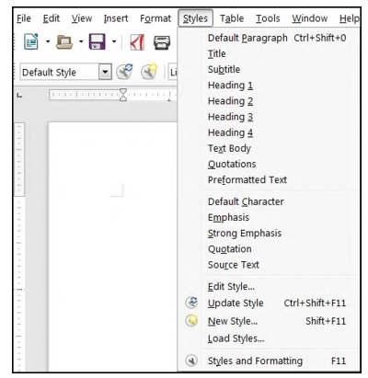

This selection is much simpler from the previous long lists shown when "styles" were selected. Similarly, a new "Sheet" menu has been added for the Calc spreadsheet programs and a new "Slide" menu has been added for the Impress presentation program (see examples of these menus below).

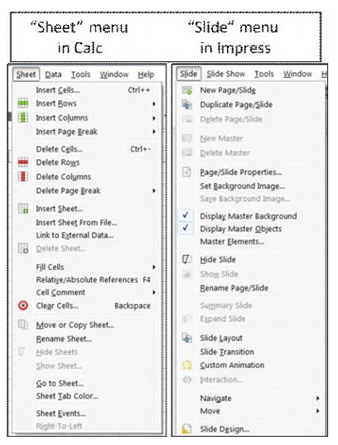

As a person who uses menus and sidebars much more than icons, I find these additional menu groupings to be a big improvement.

Go to the release notes to see the many minor changes. For example, LibreOffice can now open Gnumeric, Write, and Keynote 6 documents. As always, there is better compatibility with Microsoft Office files. If you have not updated for a while, I think this is worth the effort. You can check out the new LibreOffice at www.libreoffice.org to get a free download. Linux users may have to wait until the new version is in their repository.

